|  |
| --- |
|  |
| SPELL THE TEA |
| String project |
|  |
| Radoslav Stoychev- [RAStoychev18@codingburgas.bg](mailto:RAStoychev18@codingburgas.bg)  Bozhidar Dimitrov- [BDDimitrov18@codingburgas.bg](mailto:BDDimitrov18@codingburgas.bg)  Radina Velichkova- [RVVelichkova18@codingburgas.bg](mailto:RVVelichkova18@codingburgas.bg)  Nevena Pavlova- [NSPavlova18@codingburgas.bg](mailto:NSPavlova18@codingburgas.bg)  Mentor- Petar Georgiev |
|  |

|  |
| --- |
|  |

Contents

1. Short description of the project and objectives 1

2. Diagram describing menus 1

3. Description of the functions used 1

3.1. Purpose 2

3.2. Arguments 2

3.3. Returned value 2

# Short description of the project and objectives

The idea of our project is to help students develop their linguistic and visual skills. We created a program similar to crosswords which helps people learn different words and their definition in a very easy and fun way. The game is recommended for kids in not native English speaking countries.

# Diagram describing menus

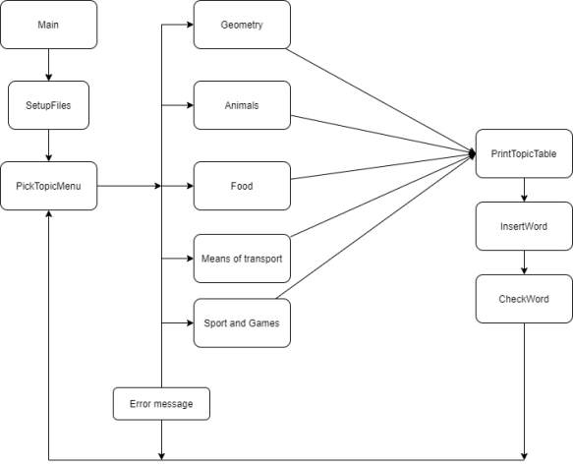

# Description of the functions used

|  |  |
| --- | --- |
| Functions | Arguments |
| Menu() | Genre& geometry ,Genre& animals, Genre& food, Genre& transport, Genre& sports |
| SetupFiles() | ifstream& geo, ifstream& ani, ifstream& fod, ifstream& trans, ifstream& sport, Genre& geometry, Genre& animals, Genre& food, Genre& transport, Genre& sports |
| checkWord() | int index, string word, Genre& genre |
| insertWord() | Genre& topic |
| printTopicWords() | Genre& topic |
| randomInt() | int minimum, int maximum |
| scrambleWord() | string original, string& word |
| toGenre() | ifstream& file, Genre& genre |

## [Purpose](bookmark://_Toc39151043/)

Menu() :

The purpose of this function is to itterate through the program and to give opportunity to the user to choose with which topic he wants to play. There are given 6 topics for the user to choose from.

SetupFiles():

SetupFiles is a startup function which has to deal with invoking the toGenre function on every file.

ToGenre():

This function extracts the needed information from the topic file, then changes it to a “Genre" datatype for the program to use later.

RandomInt():

Takes two variables –minumum and maximum. It generates and returns a random number between those two values.

PrintTopicWords():

Prints a topic in form of a table.

ScrambeWord():

Takes a word from a topic and swaps some of the letters with ‘-'.

InsertWord():

Gives the user opportunity to guess a word. It asks for index and a correct word. This is the function which invokes checkWord().

CheckWord():

Checks if an entered word is the same as the original one which the user is trying to guess.

* 1. [**Arguments**](bookmark://_Toc39151044/)

MainMenu():

This function takes 5 arguments. All of them are topic variables which we then pass in all other data and presentation functions.

SetupFiles():

This function takes 10 arguments. The first five are .txt files. The last five are Genre datatype variables. We use the files and invoke the toGenre function on every Genre argument.

ToGenre():

Only takes 2 arguments. The first one is the file the function is going to work with. The second one is of Genre type. This function takes the file and extract its data and load it to the Genre variable.

CheckWord()

CheckWord takes only 3 arguments. The first one is an index. The second is guessed word from the user and the third is the topic where the function will check wether the guess is correct or not.

InsertWord():

Takes only the topic who is going to be passed on to the CheckWord function.

RandomInt():

The fucntion takes the first and the second argument and generates a random number between them.

PrintTopicWords():

The only argument is the topic which the fucntion is going to print.

ScrambleWord():

The second argument copies the first, and the function swaps some of its elements with ‘-'.

## [Returned value](bookmark://_Toc39151045/)

MainMenu():

Returns a bool value based on which the functions itterates or not.

SetupFiles():

This is a void function. It does not return any value.

ToGenre():

This function returns a bool value based of its succes.

CheckWord():

The function returns a enumeration based on the wanted output.

InsertWord():

This is void function. It does not return any value.

RandomInt():

This function returns random intiger number.

PrintTopicWords():

This is a void function. It does not return any value.

ScrambleWord():

This Is a void function. It does not return any value.